**EXERCISE 1 – ENERGY CHANGES**

1. Explain the Law of Conservation of Energy.  
   The Law of Conservation of Energy states that energy cannot be created or destroyed, instead being either transferred (moved from one substance to another) or transformed (changed into a different type of energy). This means that in a chemical reaction, no energy is destroyed, and instead it either changes form or is moved elsewhere, which can be observed as heat, light, or sound.
2. Contrast exothermic and endothermic reactions.  
   In an exothermic reaction, the reactants have more stored energy than the products, and this energy is released from the reactants into the surroundings in the form of heat. In contrast, an endothermic reaction involves the heat energy from the surroundings being absorbed and used to fuel the reaction, resulting in the products having more stored energy than the reactants.
3. Explain how exothermic and endothermic reactions relate to the law of conservation of energy.  
   The law of conservation of energy states that energy cannot be created nor destroyed, only transformed (changed to a different type of energy) or transferred (moved from one substance to another). An exothermic reaction is an example of energy being transformed, as the chemical energy in the reactants is converted into heat energy to be released. In this scenario, no energy is created nor destroyed and can be observed as the heat being emitted. Endothermic reactions also involve energy being transformed, but in the opposite way of an exothermic reaction, as the heat energy of the surroundings is absorbed and converted to chemical energy to fuel the reaction process. In both cases, there is no change in the overall level of energy during the reaction.
4. Draw a model of the energy transfers/transformations associated with the breaking of chemical bonds.  
   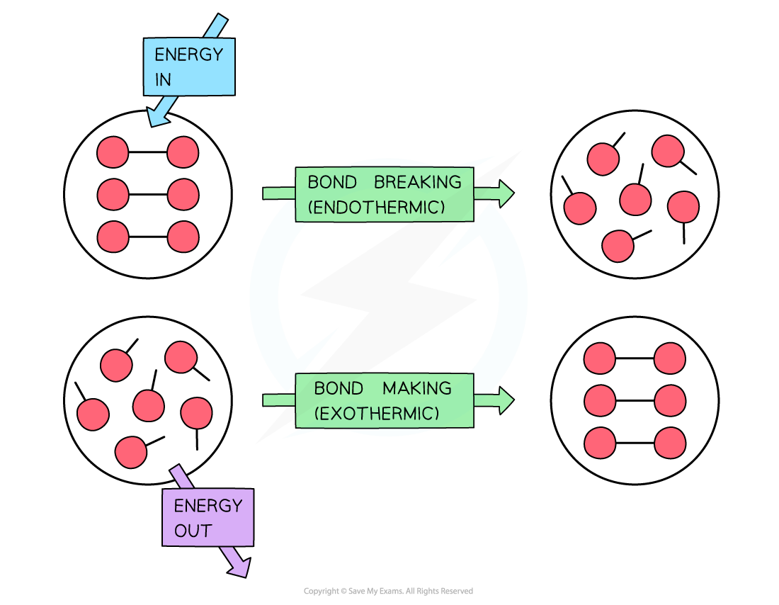
5. Draw a model of the energy transfers/transformations associated with the formation of chemical bonds.  
   
6. Explain how endothermic reactions relate to the breaking and forming of chemical bonds.  
   The breaking of chemical bonds is a process that requires energy. Endothermic reactions involve the absorption of heat energy from the surroundings, which is then transformed into chemical energy and used to fuel the process of breaking chemical bonds.
7. Explain how exothermic reactions relate to the breaking and forming of chemical bonds.  
   The formation of chemical bonds is a process that results in the loss of energy. Exothermic reactions involve the chemical energy of the reactants being transformed into heat energy through the process of forming chemical bonds, as this releases energy.
8. Predict whether the products or reactants would have more energy in an exothermic reaction.  
   In an exothermic reaction, the reactants would have more stored energy than the products, as this energy is then transformed and emitted as heat energy.
9. Explain where the additional energy comes from in an endothermic reaction.  
   An endothermic reaction involves heat energy being absorbed from the surroundings into the reactants. This gained energy allows the chemical bonds of the reactants to break and begin the reaction.
10. List observable signs of endothermic and exothermic reactions.

|  |  |
| --- | --- |
| **Reaction Type** | **Observable Signs** |
| **Endothermic** |  |
| **Exothermic** |  |